**Watson Machine Learning Overview**

This lab will introduce the Watson Machine Learning capability using the Titanic dataset. The lab will consist of the following steps:

1. Adding a data asset to the DSXL project
2. Creating a Model to predict whether a person would survive
3. Testing the Model

Step 1: Adding a Data Asset to the project

1. Download the Titanic data file from the following location by clicking on the link [Cleansed Titanic Data Set](https://github.com/jpatter/DSX_Local_Workshop_V12/blob/master/data/titanic_cleansed.csv)and following the instructions below.
2. Right-click on **Raw** and select **Save link as…**

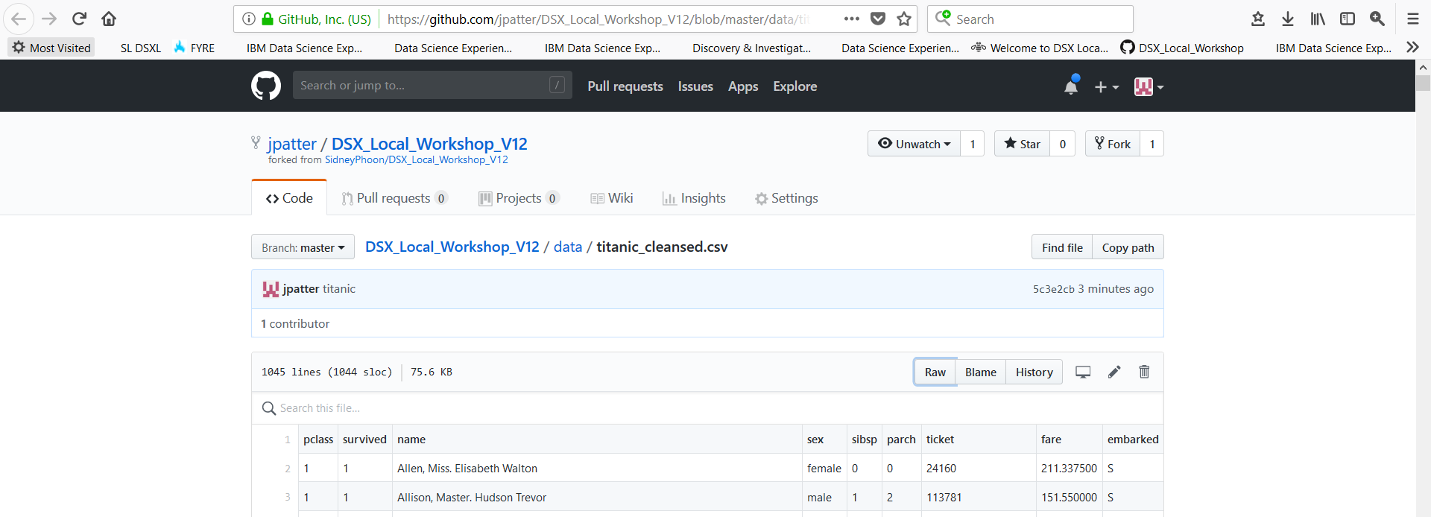

1. Save the file in your local filesystem
2. In your DSXL project go to **Data Sets** and select **add data set**

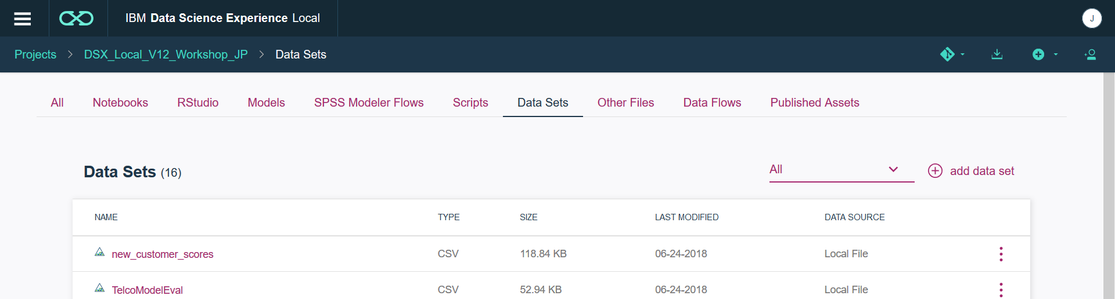

1. **Browse** or drag the **titanic_cleansed.csv** file

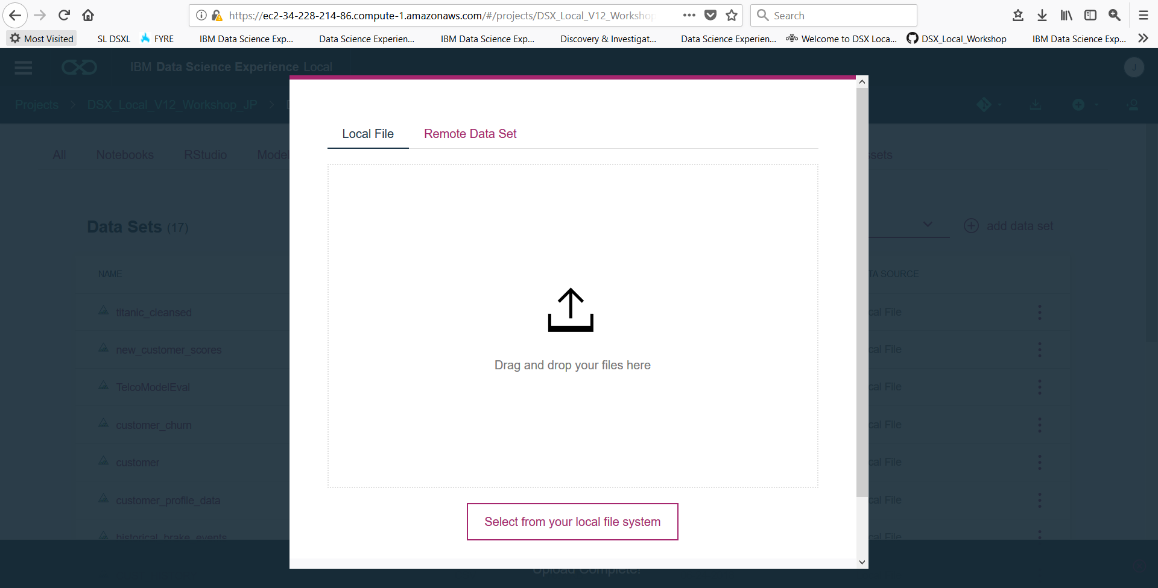

Step 2: Create a Model to predict survival

1. Select the **Models** tab

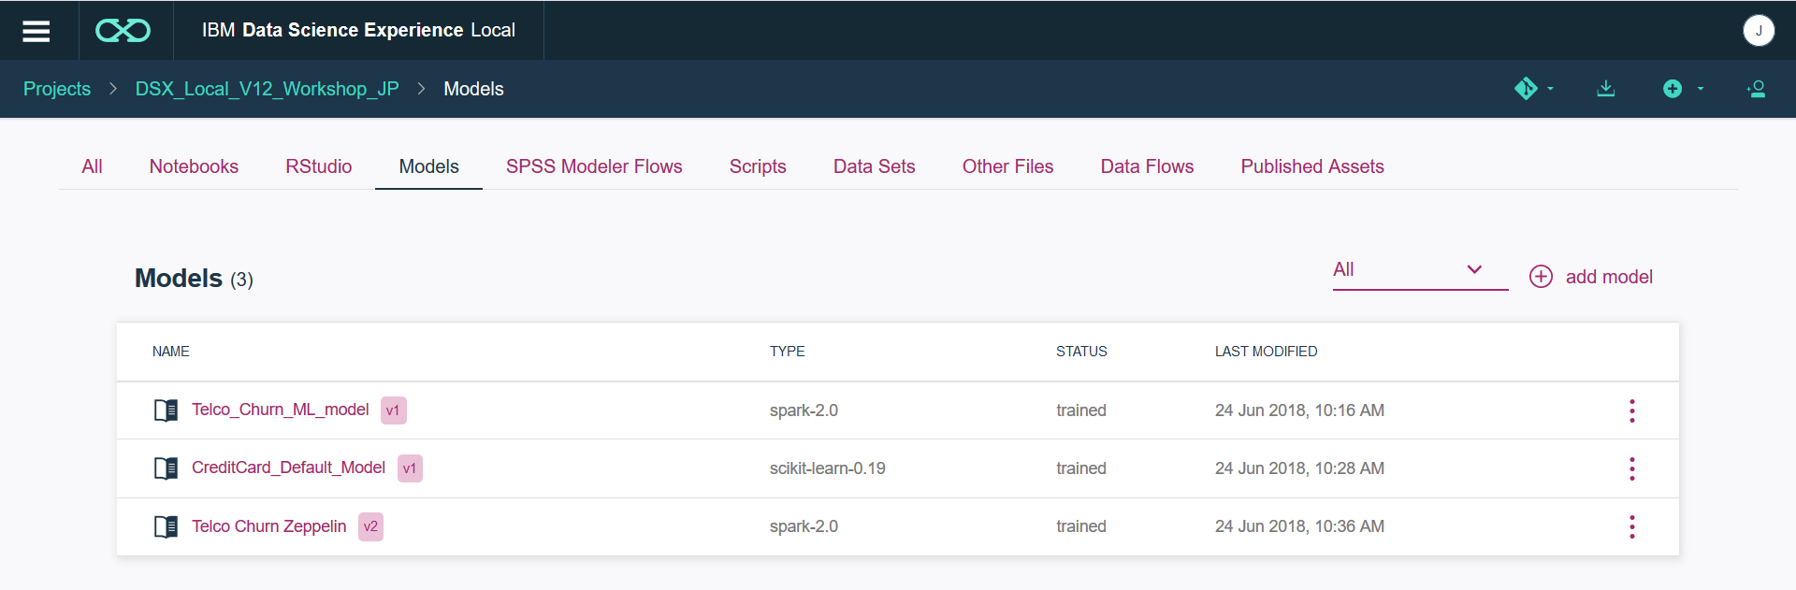

1. Select **add model**

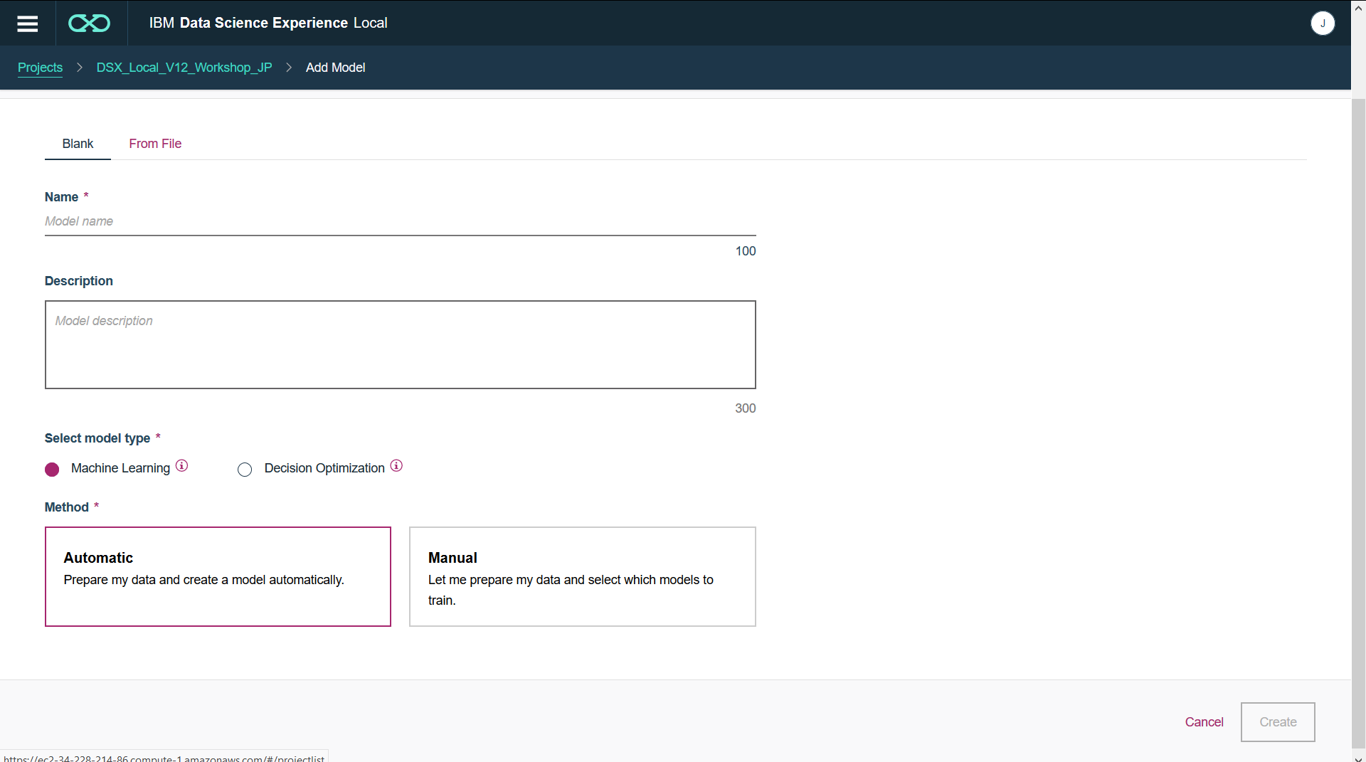

1. Enter a model **Name** (eg Titanic), optionally a **Description**, select **model type** of **Machine Learning** and select **Method** of **Manual**. Click on **Create**.

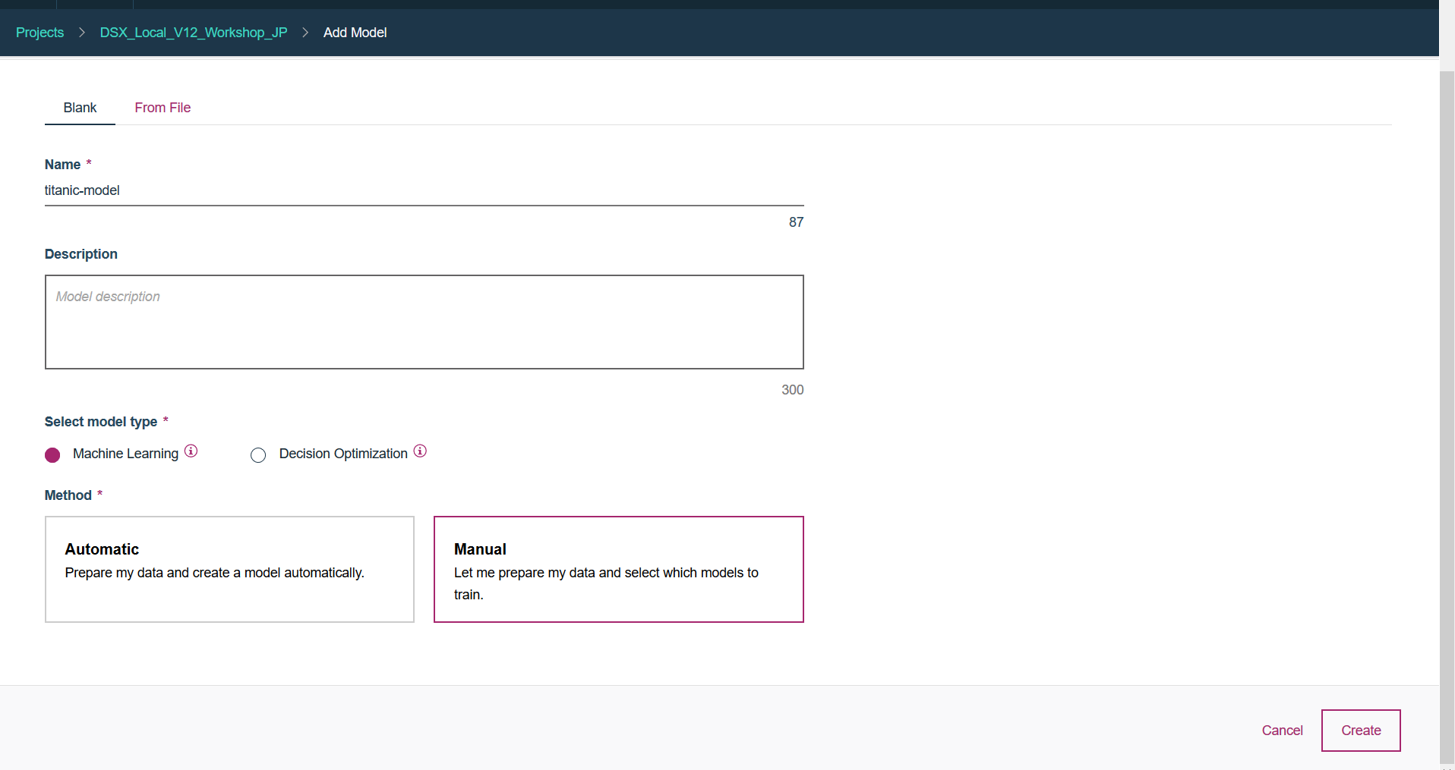

1. Click on the **titanic_cleansed.csv** and click on **Next**

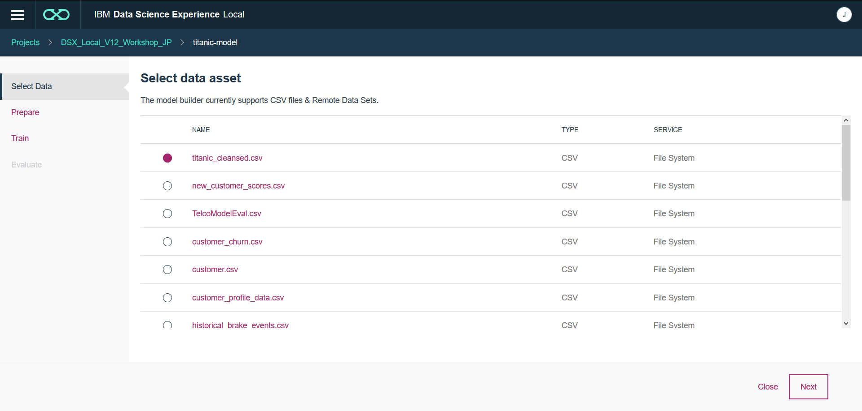

1. Select **Add a transformer** to see all available transformers. **Cancel** and use the configured **Auto Data Preparation** transformer.Select **Next.**

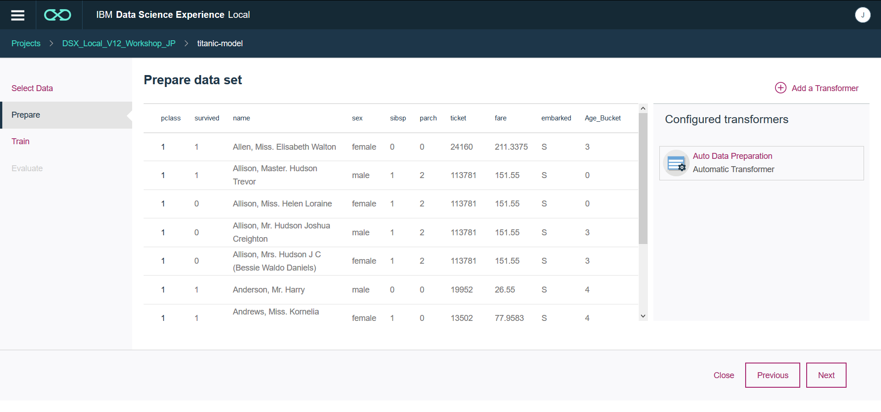

1. Select **Label Column** to **survived**. This will automatically set **Suggested technique** to Binary Classification.

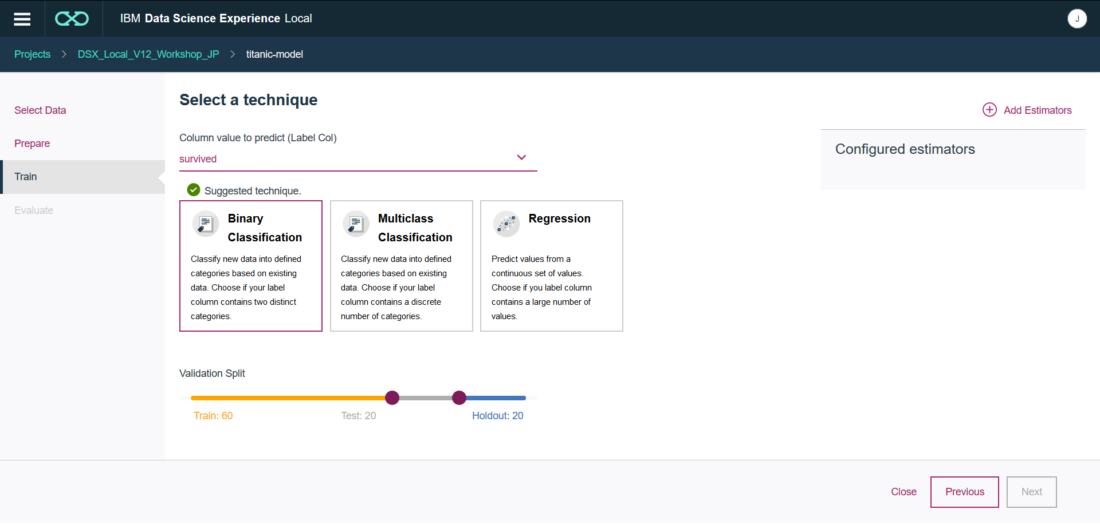

1. Select **Add Estimators.** Select all estimators and select **Add.**

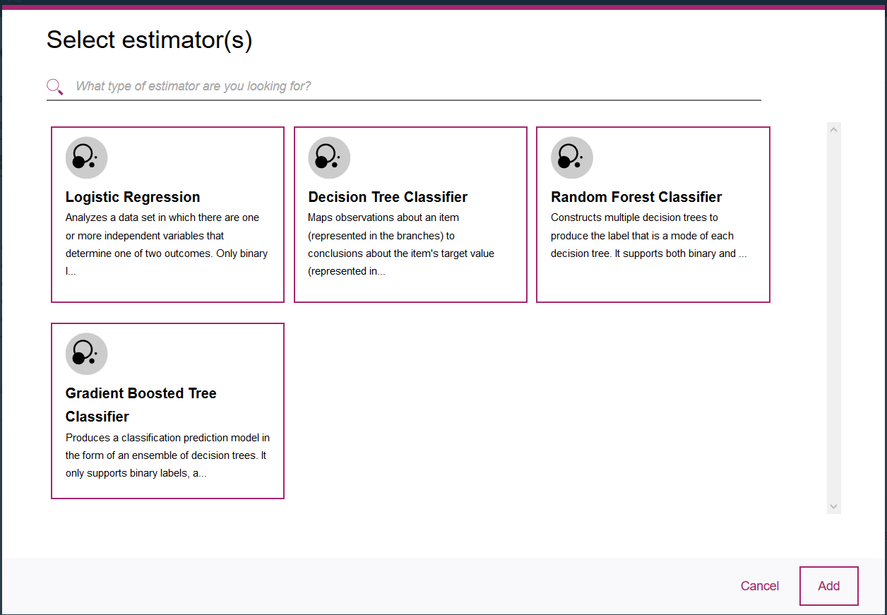

1. Select **Next.**

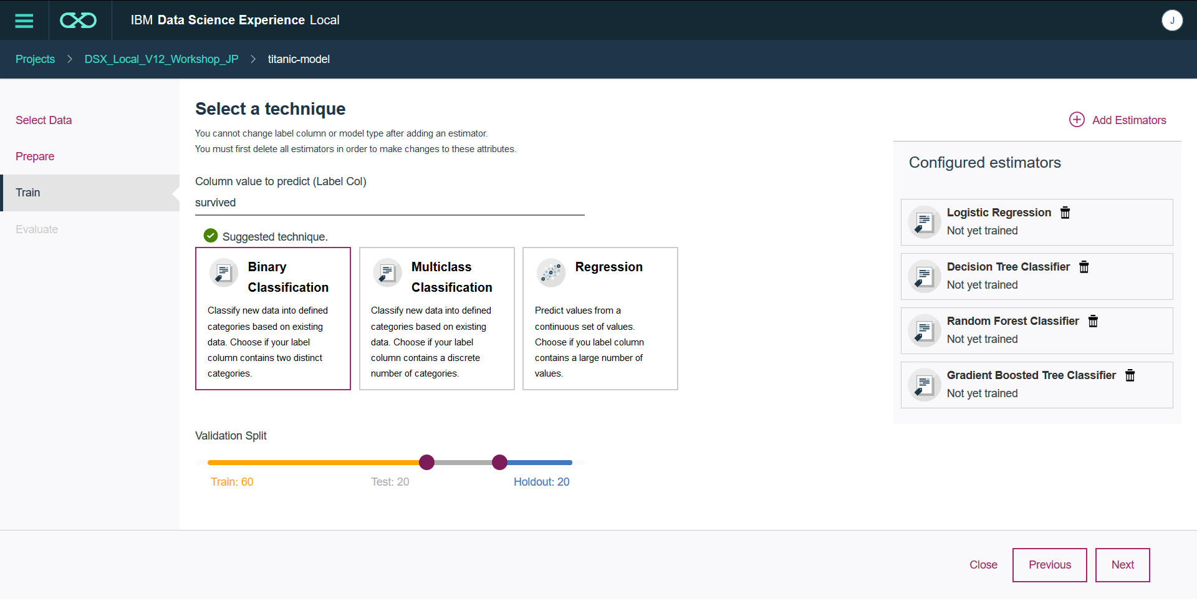

1. Wait for all models to be trained

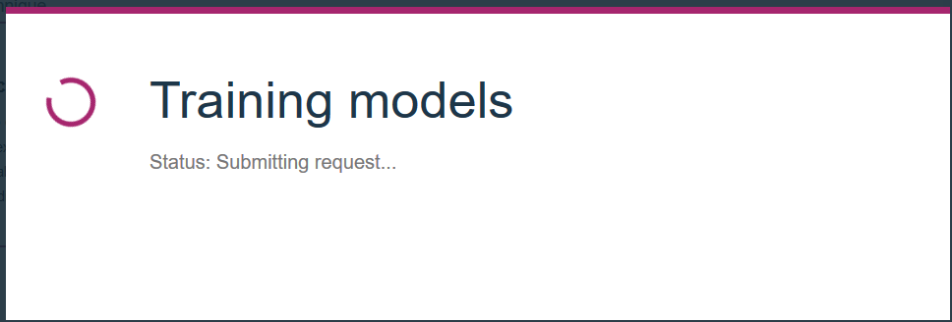

1. Review model performance. Models are ranked from best to worst performing.

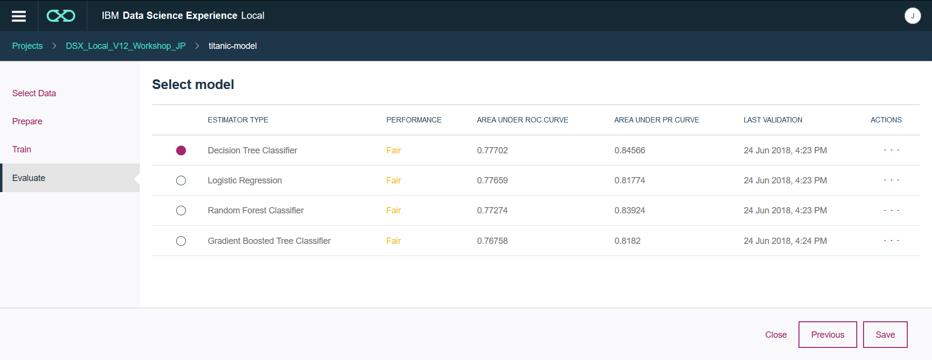

Step 3: Saving and Testing a Model

We can deploy the model to enable applications to invoke it via an API call. This is a Web Service deployment or Online deployment.

1. Select the **Save** button for the model you wish to deploy



1. Confirm the save.



1. The model now exists inside the **Models** tab of the project

